One of the topics that service technicians struggle with is when and how to replace and/or update EPROM’s and Micom’s on a unit that has had a board replaced.
First it is important to know the differences between Software-Firmware files and EPROM files. Firmware files have an extension of .HEX and ERPOM files have an extension of .SRC. EPROM and Firmware files contain 3 sections that make up the file. For Example, DB82 -03856A - 161228
The first section that starts with a DB indicates the type of file.
DB91 = Firmware – Software files.
DB82 indicates EPROM files.
The middle section identifies the component.
The last section is the date code of the file.
The date code is configured by the year, month and date.
Example, 161228 = a date code of December 28, 20016.
Firmware – Software Files:
Firmware- Software files contain the systems operation files. Firmware files tell the system’s components how to operate. These files are programmed into the board. These are listed in the S-Net software as Micom Files. For Example, a DVM S outdoor unit may display under the outdoor installation data the firmware files for the main, sub, inverter 1 &2 and fan1 & 2 board Micon versions.
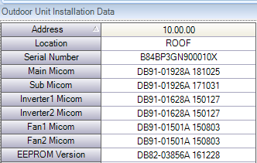
Microm – Firmware files may need to be updated to address system issues that occur in the field or to reflect different versions of equipment. If firmware is to be updated, it should be applied to fix a specific issue. Always consult a Samsung RTSM before updating the Firmware of a system.
Firmware files are preloaded on replacement boards and “typically” do not need to be updated during the installation process. If the firmware needs to be updated on a board refer to the following video for the procedure for updating / downloading software to a board. The process Is the same for indoor and outdoor boards.
Updating the IDU Micom with S-Net Pro 2 software:
https://www.youtube.com/watch?v=E36HyRNtlpI

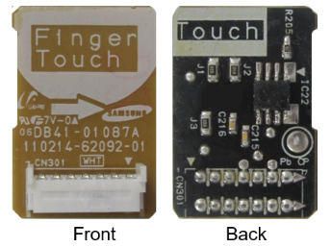
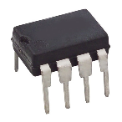
EPROM Files:
EPROM Files contain the same information and the 01-product code. They are stored on a board in one of 2 locations. These files tell the board what it is (18K 4-way mini cassette). Most boards have a removable EPROM Card. This card is easily recognizable on the circuit board. The other option (mostly used in RAC systems) is an EPROM chip. This looks like a traditional circuit board chip with 6 or 8 pins that attach to the circuit board.
When replacing a board, it is often confusing to know when to replace the EPROM and which boards come with chips or removable cards. Typically, RAC units (indoor and outdoor) use chips while CAC units (Indoor and outdoor), FJM Outdoor units and DVM s indoor and outdoor unit use a removable card.
Units with chips:
RAC Indoor and outdoor units
Units with a removable card
Everything else.

The easiest way to determine the type of ERPOM the board uses is by doing a visual inspection during the troubleshooting process. This information can also be found in the parts breakdown for the unit that Is located at https://www.samsunghvac.com
When replacing an indoor board with a removable EPROM it is recommended that you remove the EPROM from the existing board and install it into the new board. If you believe that there is an issue with the EPROM you can order a new one when ordering the board. The part number for the replacement EPROM is DB93-12483A. EPROM’s come blank and need to be programmed in the field.
When replacing an indoor board with a blank EPROM (chip or card) it will need to be set up in the field. After the board is installed and the power is connected, you’re ready to start.
There are 2 options to program the ERPOMS of an indoor unit.
1st is to enter the units 01 product into the unit using a handheld controller, wired controller or S-Net Pro 2 Software
2nd. Using the Indoor Option Writer Tab in the S-Net Pro 2 software download the SRC. File.
When replacing an outdoor main board, you will need to download the SRC file into the outdoor unit’s board using the Outdoor EPROM Write option of S-Net Pro 2 Software after the board is installed and the system is powered up. Refer to the following video as a reference.
Programming the outdoor EPROM. (same process for all units):
https://www.youtube.com/watch?v=BBTBsddW47g

UART Update
There are instances where the board will need software / firmware (.Hex files) programmed directly to the board. The UART cable and UART Update function of S-net Pro 2 allows you to directly download firmware to a board. You must have Samsung’s S-Net converter and supplied ribbon cable to do this.

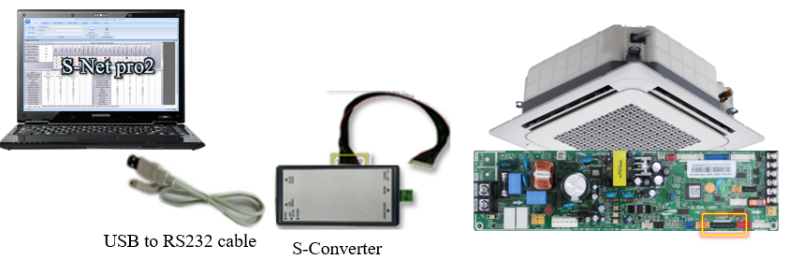
Firmware writing to a IDU board using the UART Cable:
https://www.youtube.com/watch?v=xYSY4J-8FB8

If you wish to preprogram outdoor EPROM before you ship them to your customer there is a kit available to do this. Refer to Service Bulletin 2021-001. This service bulletin can be fond at https://www.samsunghvac.com/Technical-Bulletins/service-bulletins . Reach out to your RTSM for assistance.

S-NET pro-2 Software:
The S-Net Pro 2 Software allows options for changing the 01-product code, 02 & 05 installation option codes, downloading firmware and EPROM files. There is a help section in the program that gives step by step instructions on how to use the program.
There are several TAB that can be used to perform specific function within the program. Below is a brief description of each. Detailed Instructions can be found under the help section of the S-NET pro-2 software. Refer to the add on function tab of the sub section of set layer function tab.
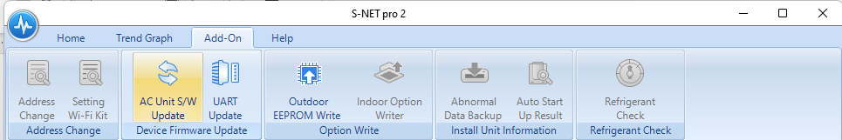
AC Unit S/W Update TAB:
This Tab is used for downloading Firmware files (HEX. File) to IDU or ODU boards. The system must be powered for this function to work. Below are the steps involved for downloading firmware files.
Click on the AC Unit S/W Update tab.
“Select Device Type: from the drop-down menu for the unit, you are working on.
“Update file path”: select the HEX. File for the unit you are working on.
Click the address of the unit you want to update.
Click “Start”
A dialogue box will appear next to the unit you selected displaying the progress of the download.

UART Updates TAB: (Firmware Updates, HEX. files)
The UART Tab is used to directly download firmware to an unpowered indoor, outdoor or MCU board.
Connect the S-Net converter ribbon cable to the “Download" connector of the board and the S-Net converter. Make sure the Target Switch is in the off position.
Click the UART Update tab
Click on “Update File Path” and select the HEX. File for the unit you are working on.
Click “Start”
When the screen displays “waiting for reply from PCB) turn the “Target” switch on the S-net converter from OFF to ON.
The display will show “download started” and the progress of the download.
Once the file had downloaded successfully disconnect the ribbon cable and install the board in the unit.

Outdoor EPROM Writer TAB: (SRC. File)
This tab is used to program the ERPOM of an outdoor unit,
Click on the Outdoor EPROM Writer Tab
Select the unit you want to program.
Click on “Open Option File” and select the file to be downloaded.
Click “Write Option” to start the download.

Indoor Option Writer TAB: (SRC. File)
This section is used to change the 01-product code, 02 installation code and 05 installation code of an indoor unit(s).
There is an option within the indoor option writer to select and download the SRC. file for a given unit.
Inputting 01 product, 02 & 05 installation codes:
Click on the “Indoor Option Writer” tab
Select the indoor or multiple indoor units to be programmed.
Enter the code in the appropriate section.
Verify the code is correct
Click “Write Option”
The progress of the download will be displayed next to the unit.
Once “Download Successful” is displayed you can close the window,
The new code will appear on the S-Net Pro 2 software in several minutes.

Downloading a SRC File.
Click on the “Indoor Option Writer” tab
Select the indoor or multiple indoor units to be programmed.
Cick “open Option File and select the correct file for the unit.
Click “Write Option”
The progress of the download will be displayed next to the unit.
Once “Download Successful” is displayed you can close the window,
The new code will appear on the S-Net Pro 2 software in a several minutes.

If you have any questions or need assistance please contact your Samsung RTSM.

